Matt Brothen

Unit 2 Apply

Question 6 A:

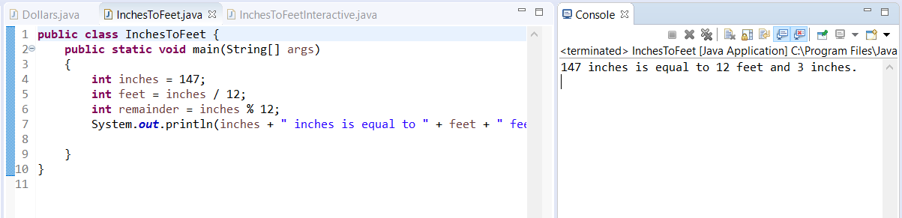

Question 6 B:

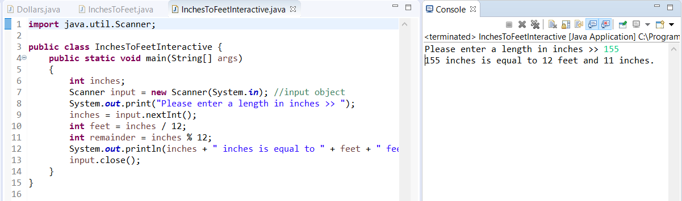

Question 10:

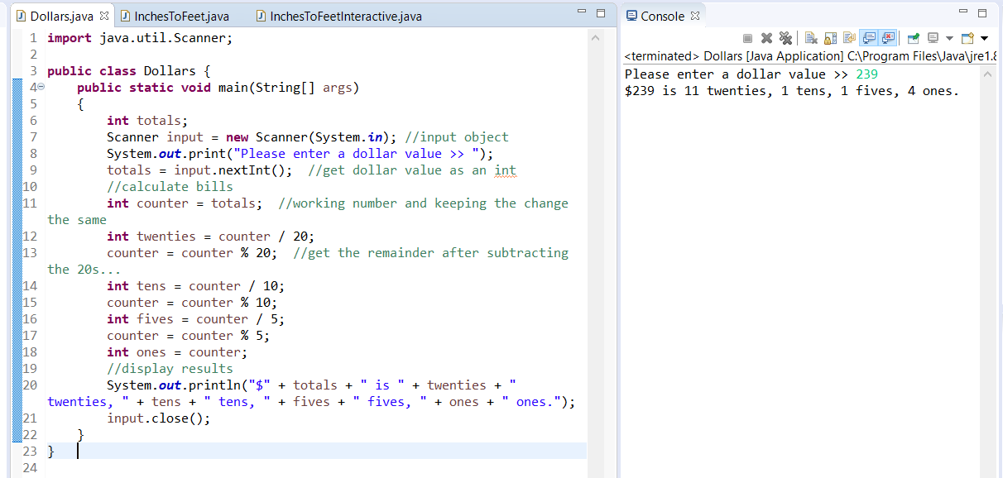

This would have been more difficult without modulus.